1. **Attributes**

We developed a piece of code that can preprocess any dataset to make it compatible with the TE model. Our approach involves initially removing certain variable attributes to see whether the data can still run through the TE model without errors, allowing us to identify which attributes are essential for the model. We then plan to check whether each variable in the input data has the necessary attributes, and automatically fill in any missing attributes if they are absent.

We systematically removed attributes such as missing_value, fmissing_value, long_name, standard_name, vamx, and vmin from the TE-ready data.

Here is the code:

import xarray as xr

input_file = '/home/zy2608/tempest_project/ERA5_TE_ready_2022_modified_v5.nc'

output_file = '/data0/zy2608/ERA5_TE_ready_2022_modified_v5_no_vmax.nc'

era5_ds = xr.open_dataset(input_file)

def remove_vmax_attribute(era5_var):

if 'vmax' in era5_var.attrs:

print(f"Removing 'vmax' attribute from variable '{era5_var.name}'")

del era5_var.attrs['vmax']

return era5_var

for var_name in era5_ds.data_vars:

era5_ds[var_name] = remove_vmax_attribute(era5_ds[var_name])

for coord_name in era5_ds.coords:

era5_ds.coords[coord_name] = remove_vmax_attribute(era5_ds.coords[coord_name])

era5_ds.to_netcdf(output_file)

print(f"New NetCDF file has been saved as {output_file}, 'vmax' attribute has been deleted.")

Interestingly, when we individually removed these attributes and ran the updated data through the TE model, the model continued to function without any issues. This behavior is quite unexpected, and we are unsure why the model still runs normally despite the removal of these attributes.

This is the attribute after remove vmax:

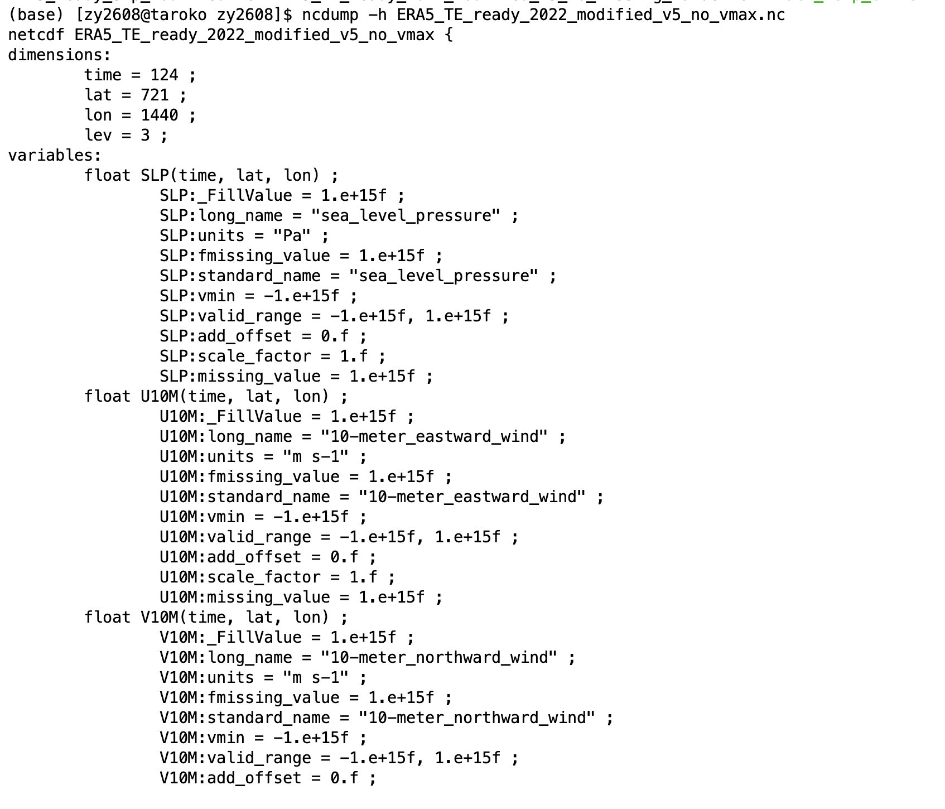

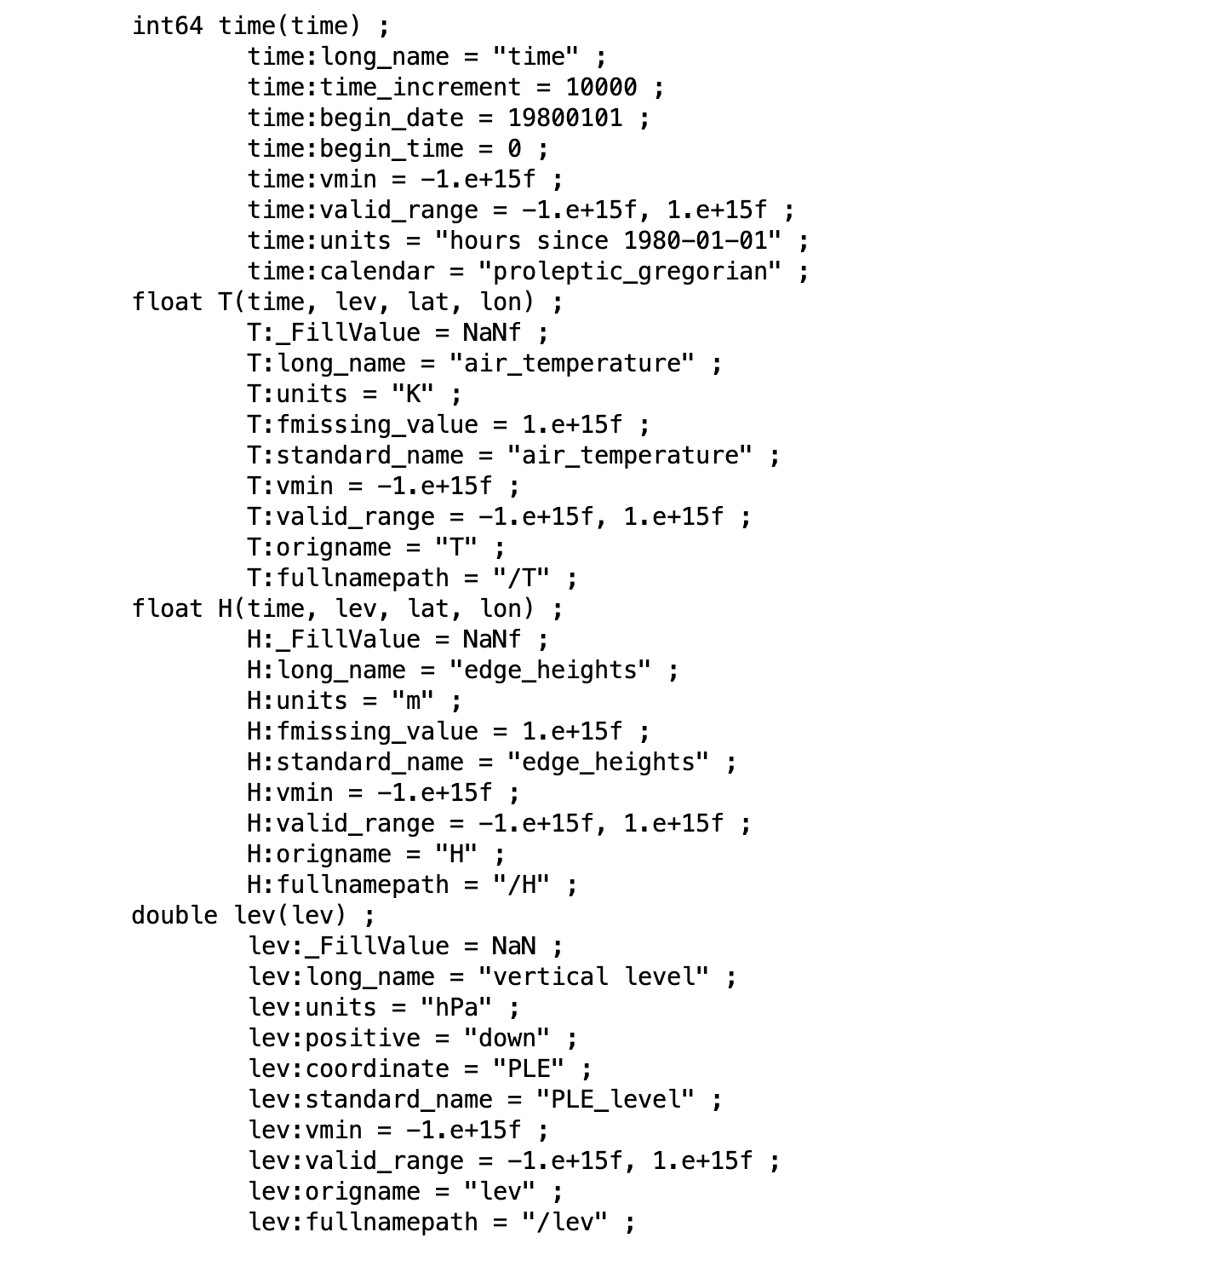

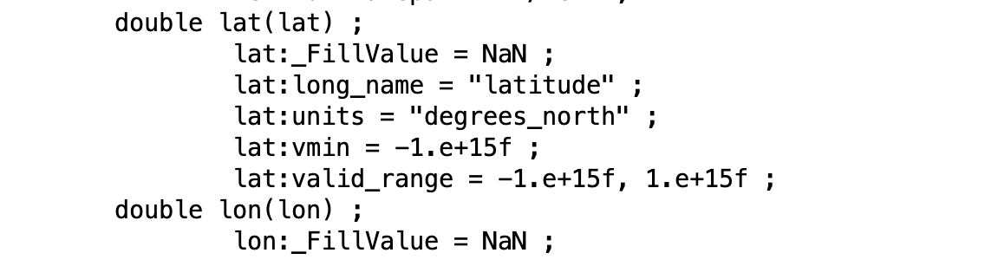

Then we use the updating data to run the TE model:

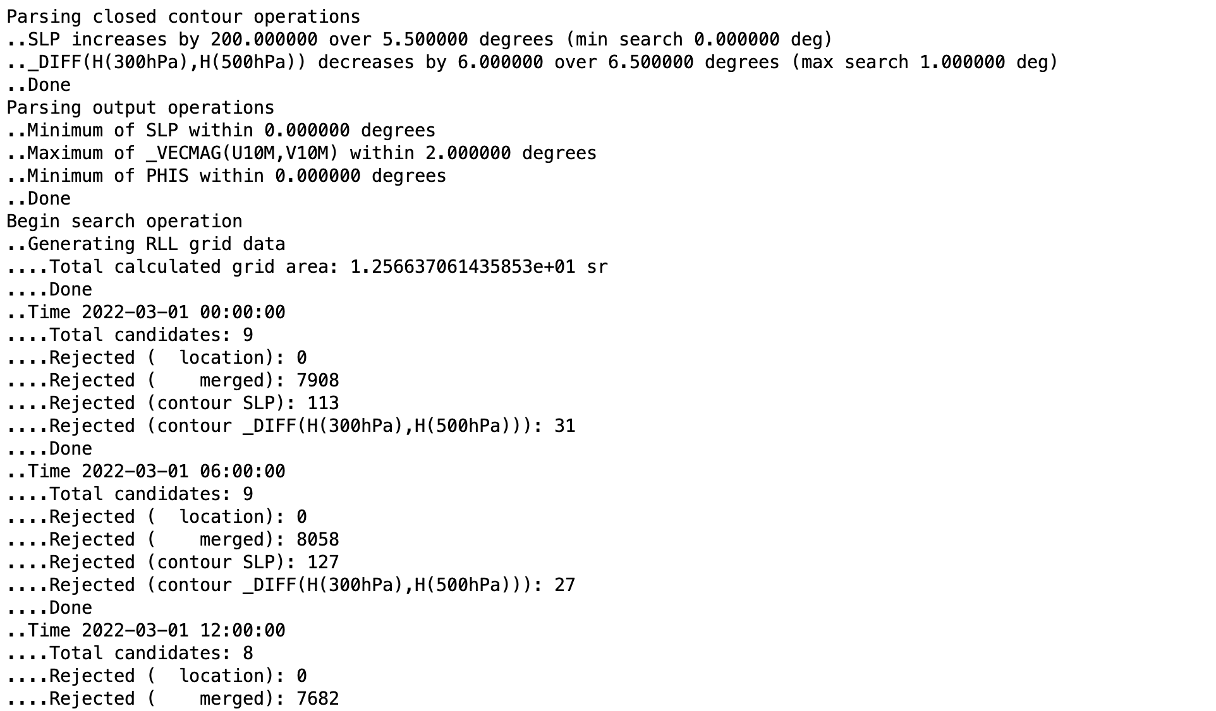

1. **Intensity**

We visualized the data obtained from the TE model by creating a storm plot for the year 2022, using wind speed as the label. However, we encountered an issue with the data, as the wind speeds we obtained were surprisingly low. We hypothesize that this could be due to the fact that we are only selecting data from four time points per day, which might not capture the maximum wind speeds for many storms. Here is the graph:

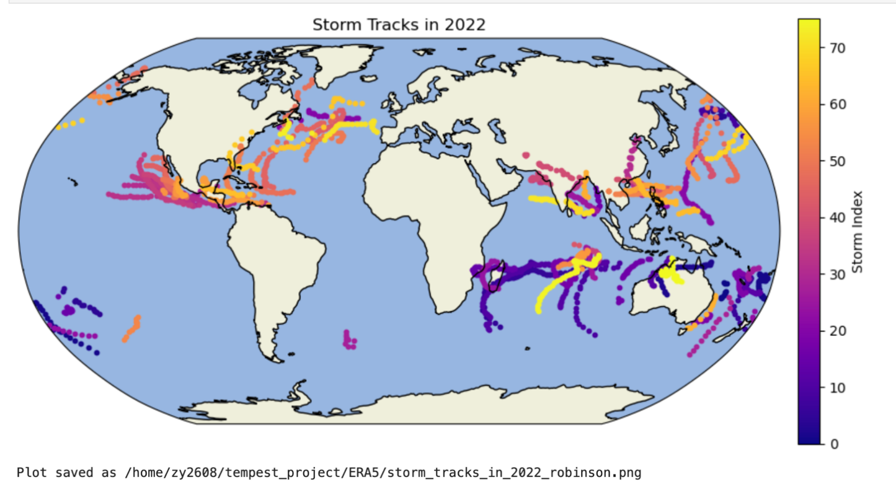

Below is the track of storm in 2022 based on the IBTrACS:

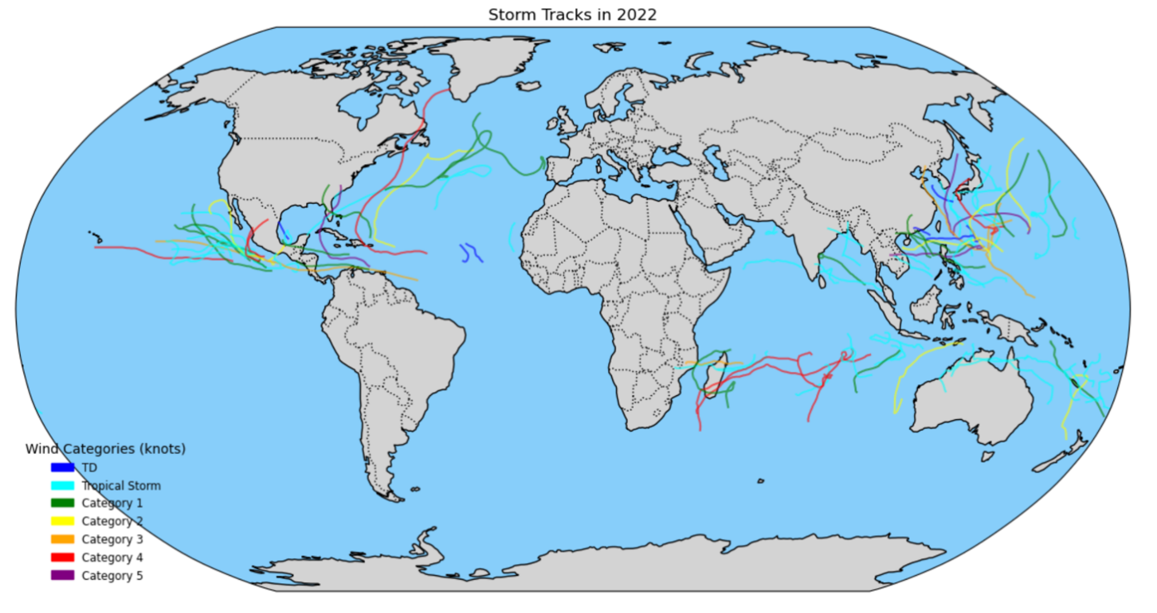

After extracting the 2022 ERA5 data and reanalyzing it using TE, we processed the resulting file, named ***EAR5_second_trail.dat***, with ***convert_data.py*** to label the data, generating the file ***convert_dataset.dat***. (wind speed)

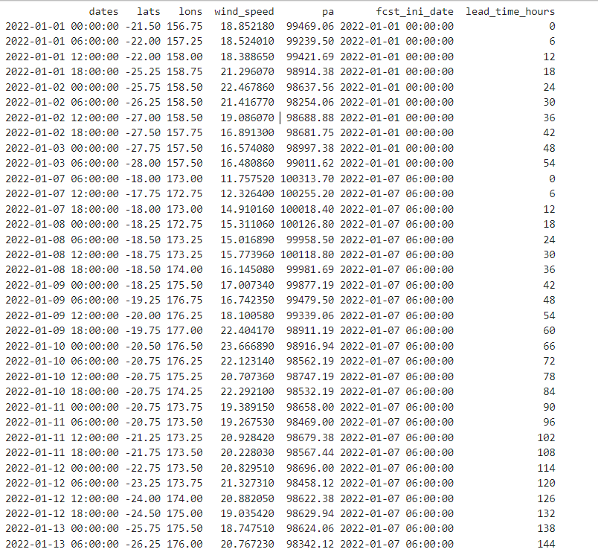

We then compared this file with the Saffir-Simpson scale and used ***Saffir–Simpson_graph.py*** to generate the plot below.

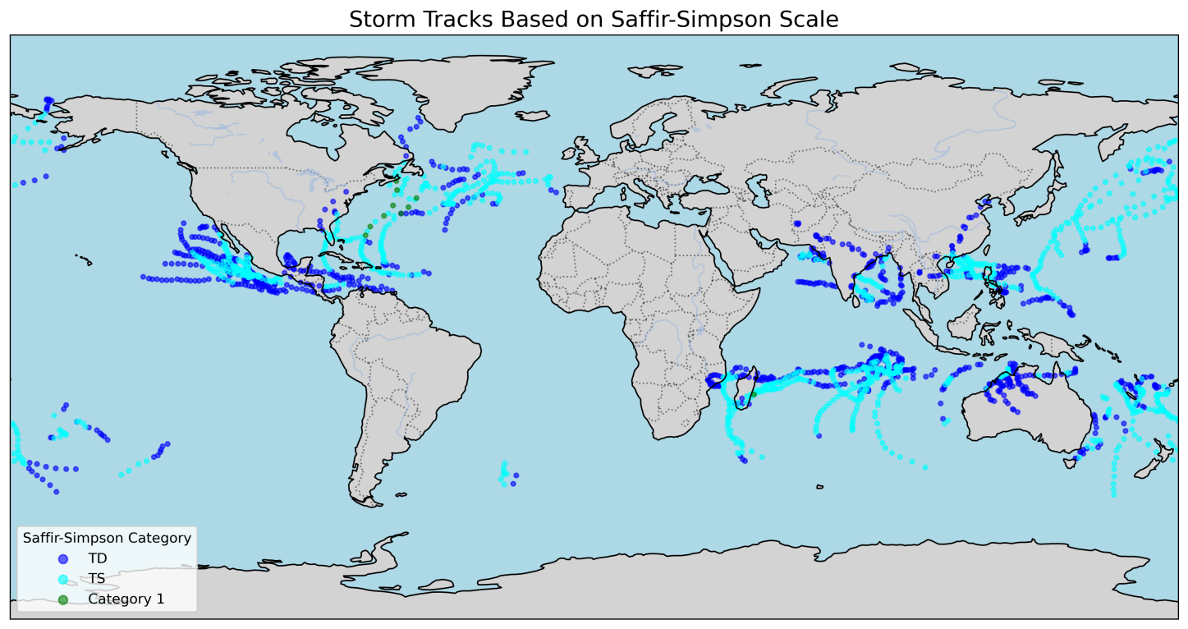

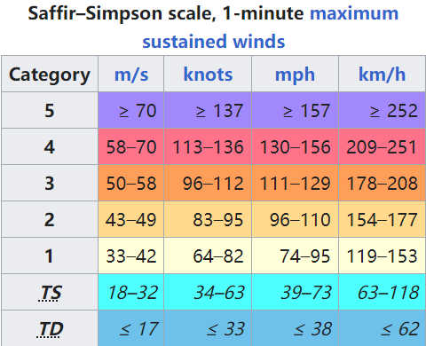

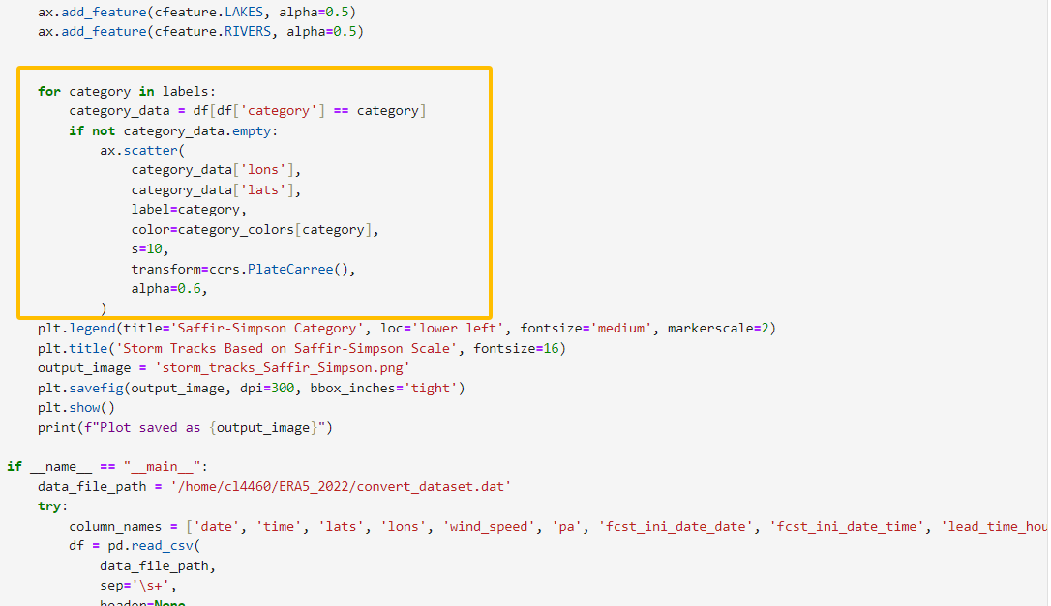

However, when we attempted to change the scattered points in the image to continuous lines, I modified the following part of the code, but the result was not satisfactory.

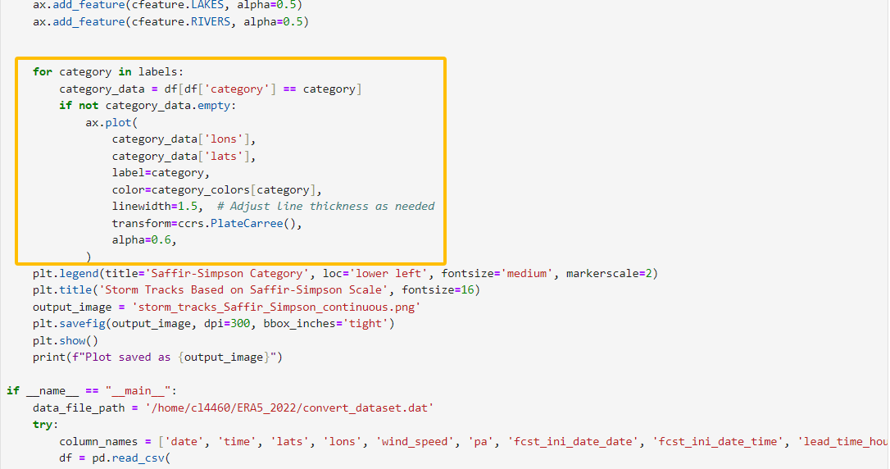

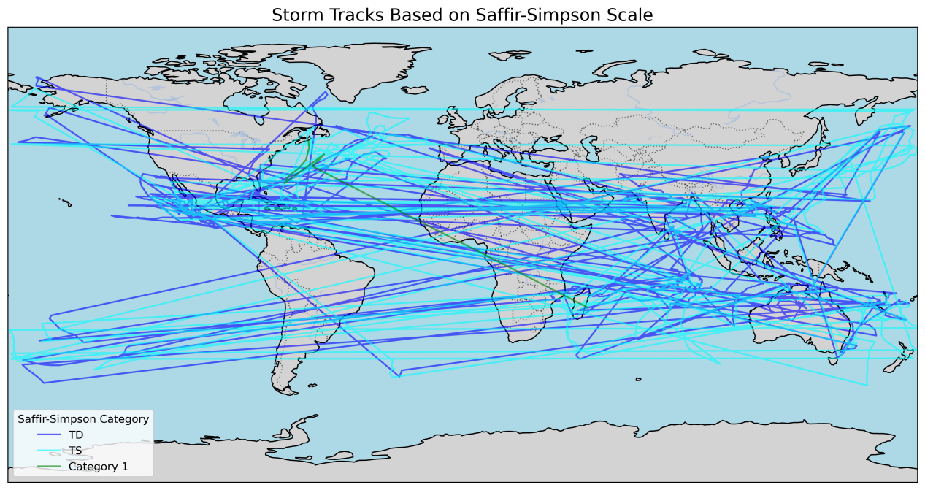

The last thing should be comparsion:

